Board
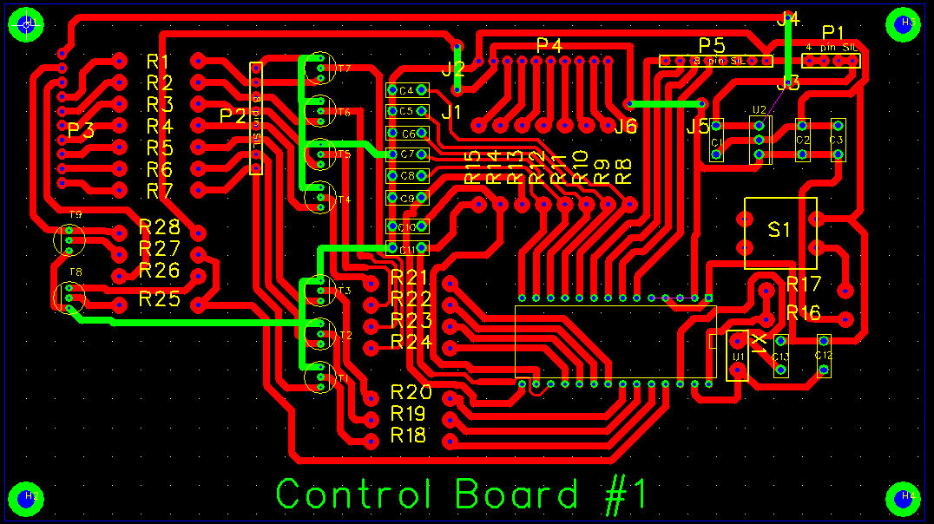

P1 Input
Pin 1 12V input
Pin 2 12V To relays
Pin 3 0V input
Pin 4 0V To LEDs
P2 Relays - Outputs
Pin 1 RC6 Atten
Pin 2 RC5 24/28 MHz
Pin 3 RC4 18/21 MHz
Pin 4 RC3 10/24 MHz
Pin 5 RC2 7 MHz
Pin 6 RC1 3.5 MHz
Pin 7 RC0 1.8 MHz
Pin 8 0V Input
P3 LEDs - Outputs
Pin 1 +12V O/p to LEDs
Pin 2 RC7 Eltek later?
Pin 3 RC7 HT on LED
Pin 4 RC0 1.8 MHz
Pin 5 RC1 3.5 MHz
Pin 6 RC2 7 MHz
Pin 7 RC3 10/24 MHz
Pin 8 RC4 18/21 MHz
Pin 9 RC5 24/28 MHz
Pin 10 RC6 Atten

P4 Buttons - Inputs
Pin 1 RB0 1.8 MHz
Pin 2 RB1 3.5 MHz
Pin 3 RB2 7 MHz
Pin 4 RB3 10/14 MHz
Pin 5 RB4 18/21 MHz
Pin 6 RB5 24/28 Mhz
Pin 7 RB6 Atten
Pin 8 RB7 HT on
Pin 9 5V
Pin 10 0V

P5 Link to #2 board
Pin 1 0V
Pin 2 ptt relays
Pin 3 n/c
Pin 4 ptt input
Pin 5 RA0
Pin 6 RA1
Pin 7 RA2
Pin 8 RA3

